County Run Book

Colorado Risk Limiting Audit Tool v1.0.0 alpha-2

2017

Table of Contents

Introduction 1

County Admin Functions 2

Launching and Logging In 2

Navigation 3

Ballot Manifest and CVR File Uploads 5

Monitoring the Audit 10

Audit Board Functions 10

Audit Board Sign In 12

Ballot Card Retrieval 13

Ballot Card Review 16

End of Round 23

Signing out the Audit Board for Breaks 23

Ending the Audit 24

Audit Reports 25

# Introduction

This Run Book guides County election administrators who will be implementing a Risk Limiting Audit (RLA) with a comparison audit. The RLA Tool, developed by Free & Fair for the Colorado Department of State for use in elections in November 2017 and later, supports running a Risk-Limiting Audit as required by Colorado statute and as specified in the [Colorado Secretary of State's Rule 25](http://www.sos.state.co.us/pubs/rule_making/CurrentRules/8CCR1505-1/ElectionRules.pdf) for elections.

Orange arrows on the screenshots indicate features described in the text of the Run Book.

# County Admin Functions

## Launching and Logging In

A County user can launch the RLA Tool by pointing a browser to the URL provided by the Colorado Department of State.

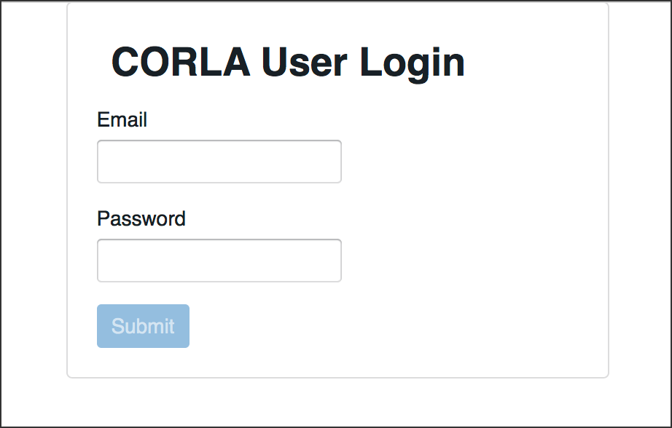

Login

Successful entry of username and password will lead to a two-factor authentication grid challenge.

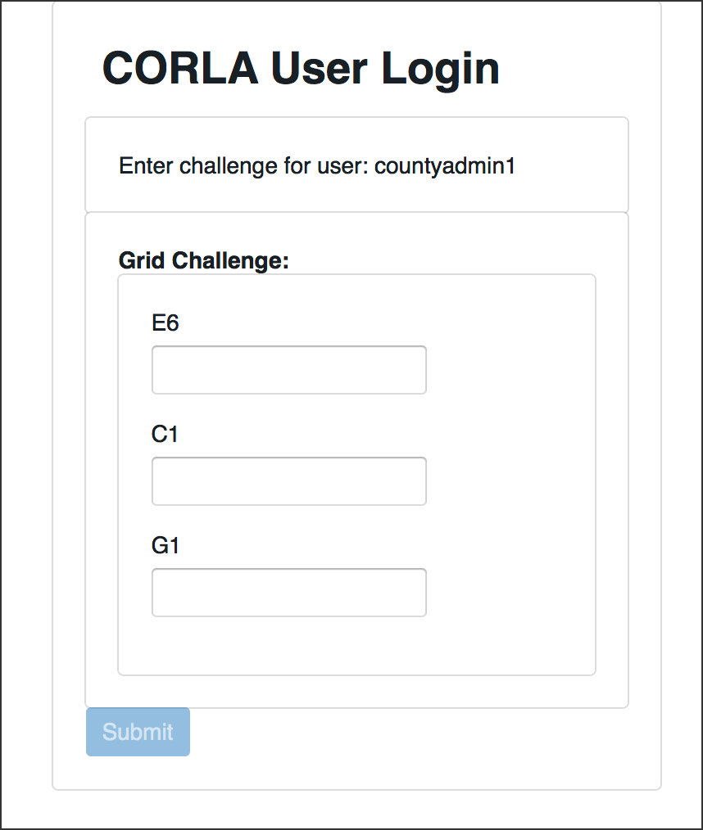

Grid Challenge

## Navigation

Once two-factor authentication is complete, County users will see the County Home Page and can enter the information to set up the audit.

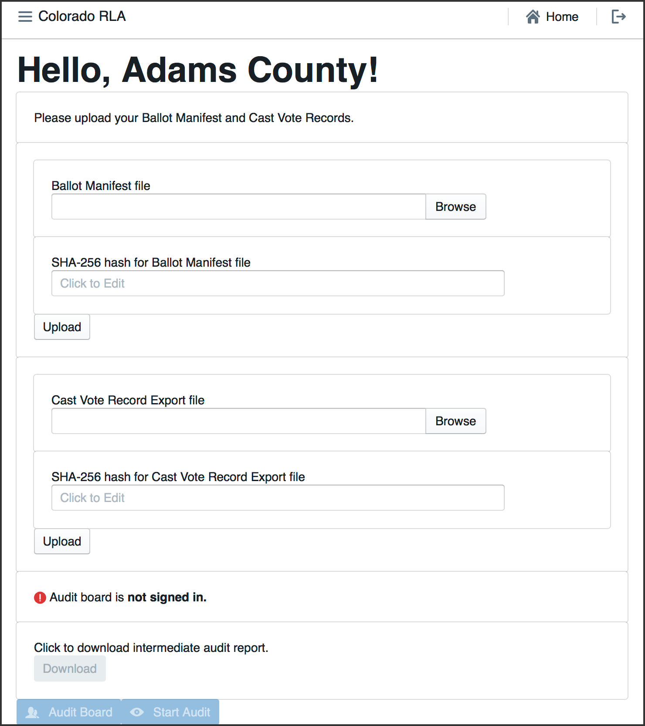

County Home Page at Start

In the upper left corner of every page the County site has a menu that can be used to navigate to the County Home Page, the Audit Board Sign-In/Out pages or the Audit (Ballot Review) pages. Click on the navigation icon to bring up the navigation menu.



Navigation Icon

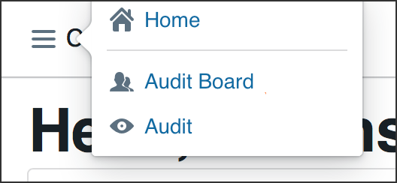

Navigation Menu

In the upper right corner of each page is a button to return to the County Home Page



Home Button

and a button to log out of the system altogether.



Logout Button

## Ballot Manifest and CVR File Uploads

To prepare for upload, the County's ballot manifest and CVR files must each be hashed using any SHA-256 hash utility. The RLA Tool itself does not provide a utility for hashing, but uploaded files are verified against the provided hash.

Once the ballot manifest and CVR files are hashed, they can be uploaded into the RLA Tool. If the upload is interrupted, the process will have to be repeated. It is not possible to resume an interrupted upload—just start that file upload again. If a County uploads multiple Ballot Manifest files, only the data from the last file will be used. Similarly, if a County uploads multiple CVR files, only the data from the last file will be used. To upload the ballot manifest:

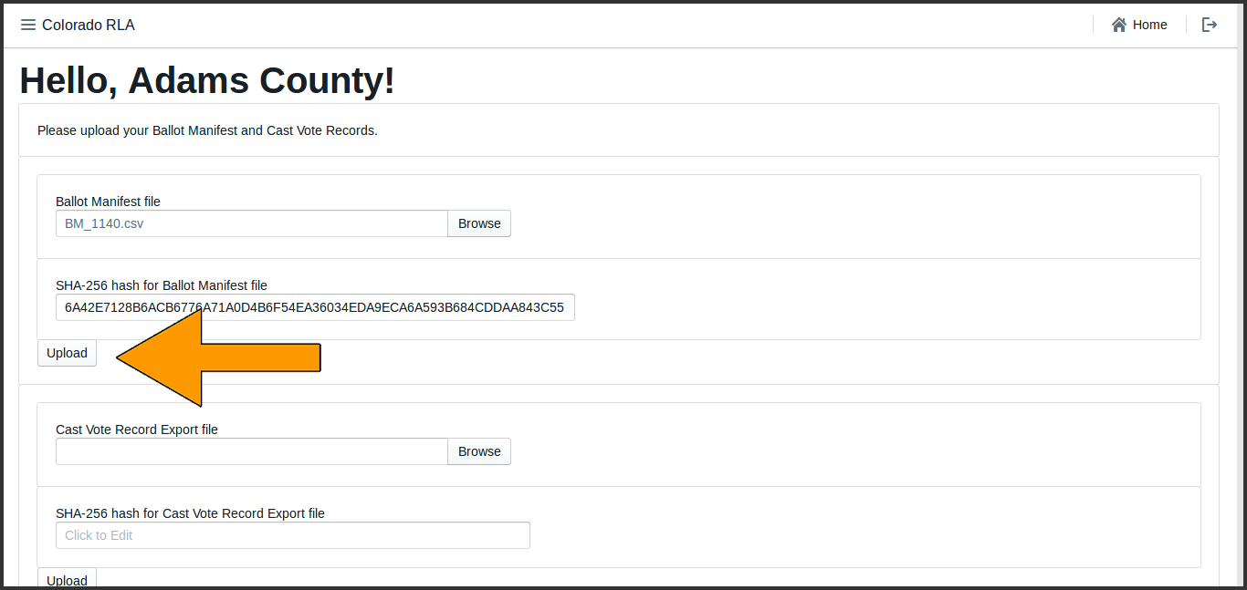

To upload the CVRs:

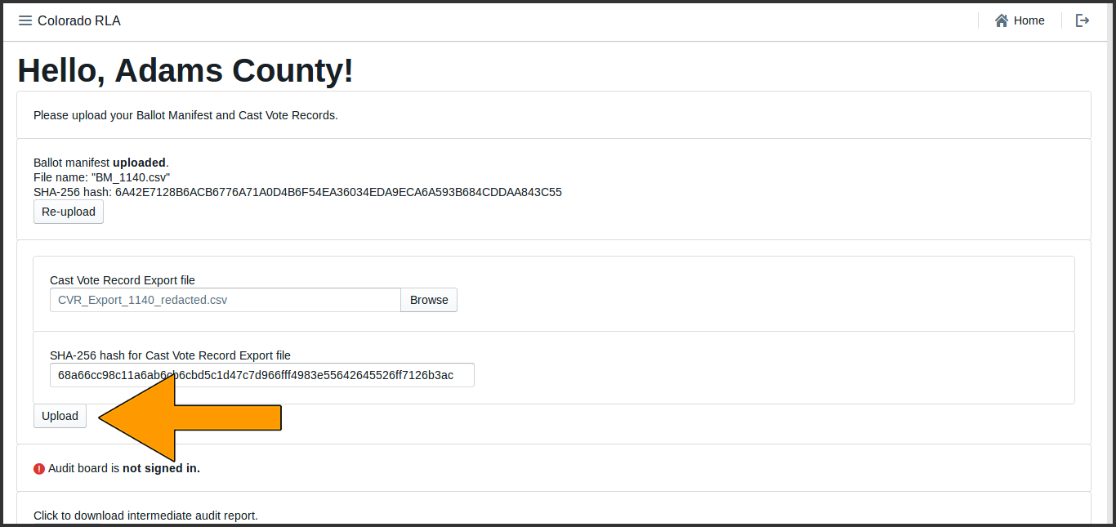

If the hash does not match the file (either because the wrong hash was entered, or because the file was changed as it traveled over the network), the data from the file will be uploaded but the data will not be imported. The user will see the following messages.

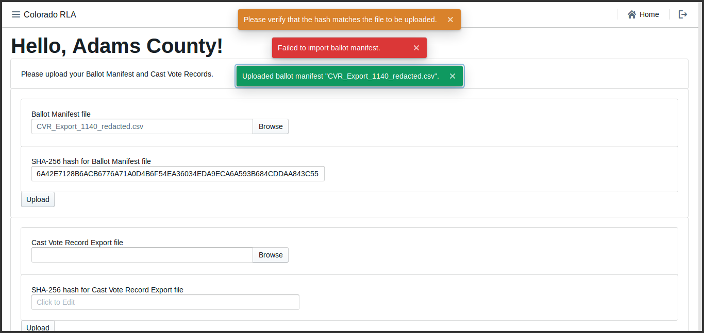

Hash Mismatch Error

**Remedies and Mitigations**

In this situation, please double-check that you have: (a) chosen and uploaded the correct file, (b) hashed the correct file, (c) use the correct kind of hash (it must be SHA-256), and (d) copied the entire hash code into the appropriate text box.

If the hash matches the file but the file is not in the proper format, the data from the file will not be imported. The user will see the following messages.

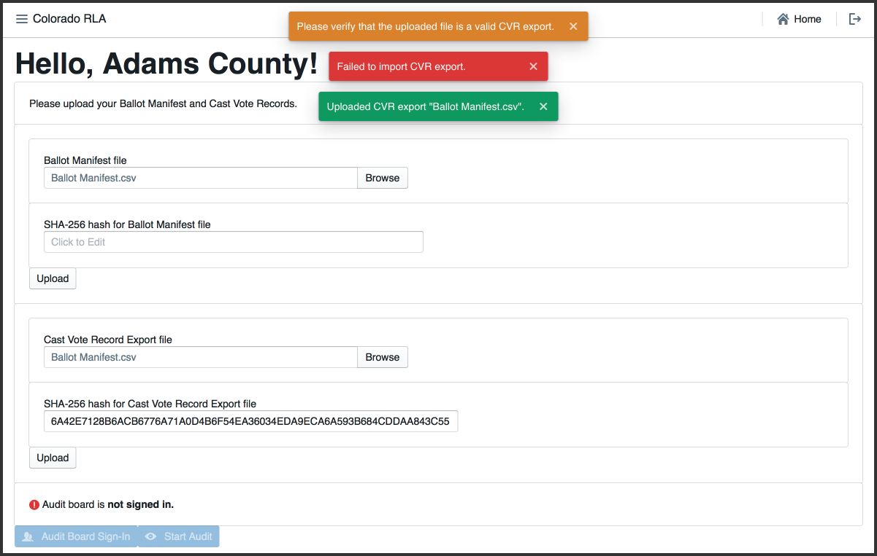

Format Error

If the hash matches and the file format is correct, the system will import the data from the file. The user will see the following messages.

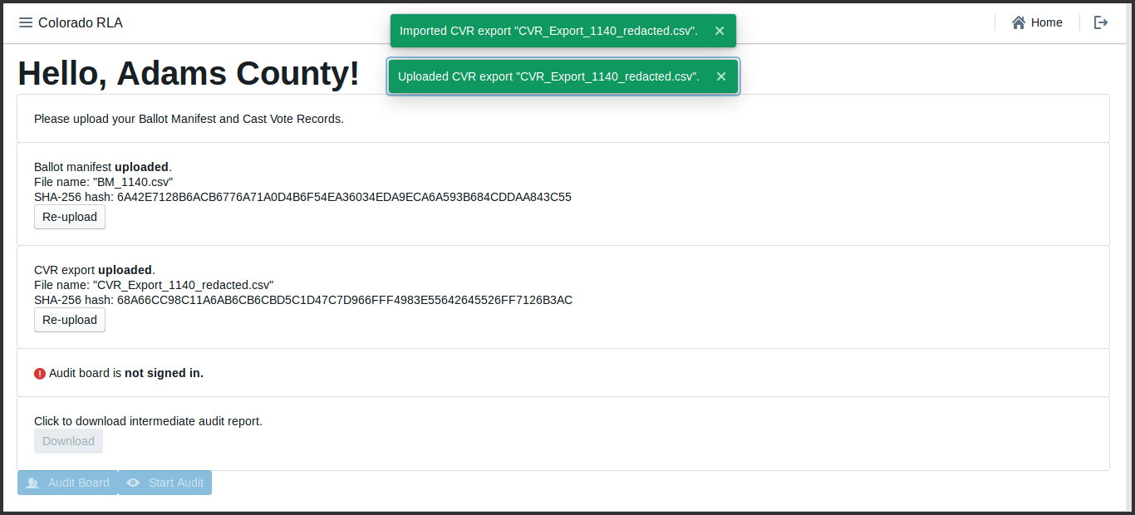

File Uploads Successful

**Remedies and Mitigations**

In this situation, please double-check that you have: (a) chosen and uploaded the correct file, (b) removed the "CountingGroup" column from the CVR file, (c) not edited or tampered with the file in any other fashion, and (d) are uploading a CSV file, not a JSON file.

The time required for data import depends on the size of the file. Import time for the CVR file will depend on the number of ballot cards represented in the file. A file with fewer than 10,000 CVR lines should take less than a minute, while a file with 500,000 CVR lines or more might take about a half hour. The ballot manifest file upload and import will be quicker than the CVR file upload and import.

Once both the ballot manifest and CVR files are successfully uploaded and imported users will see them both listed as **uploaded**. It is possible to re-upload either or both files, if necessary.

After successfully upload and import of both the Ballot Manifest and the CVR files, the Contest Info table near the bottom of the County Home Page lists all contests from the CVR file. The user may have to scroll down to see all contests.

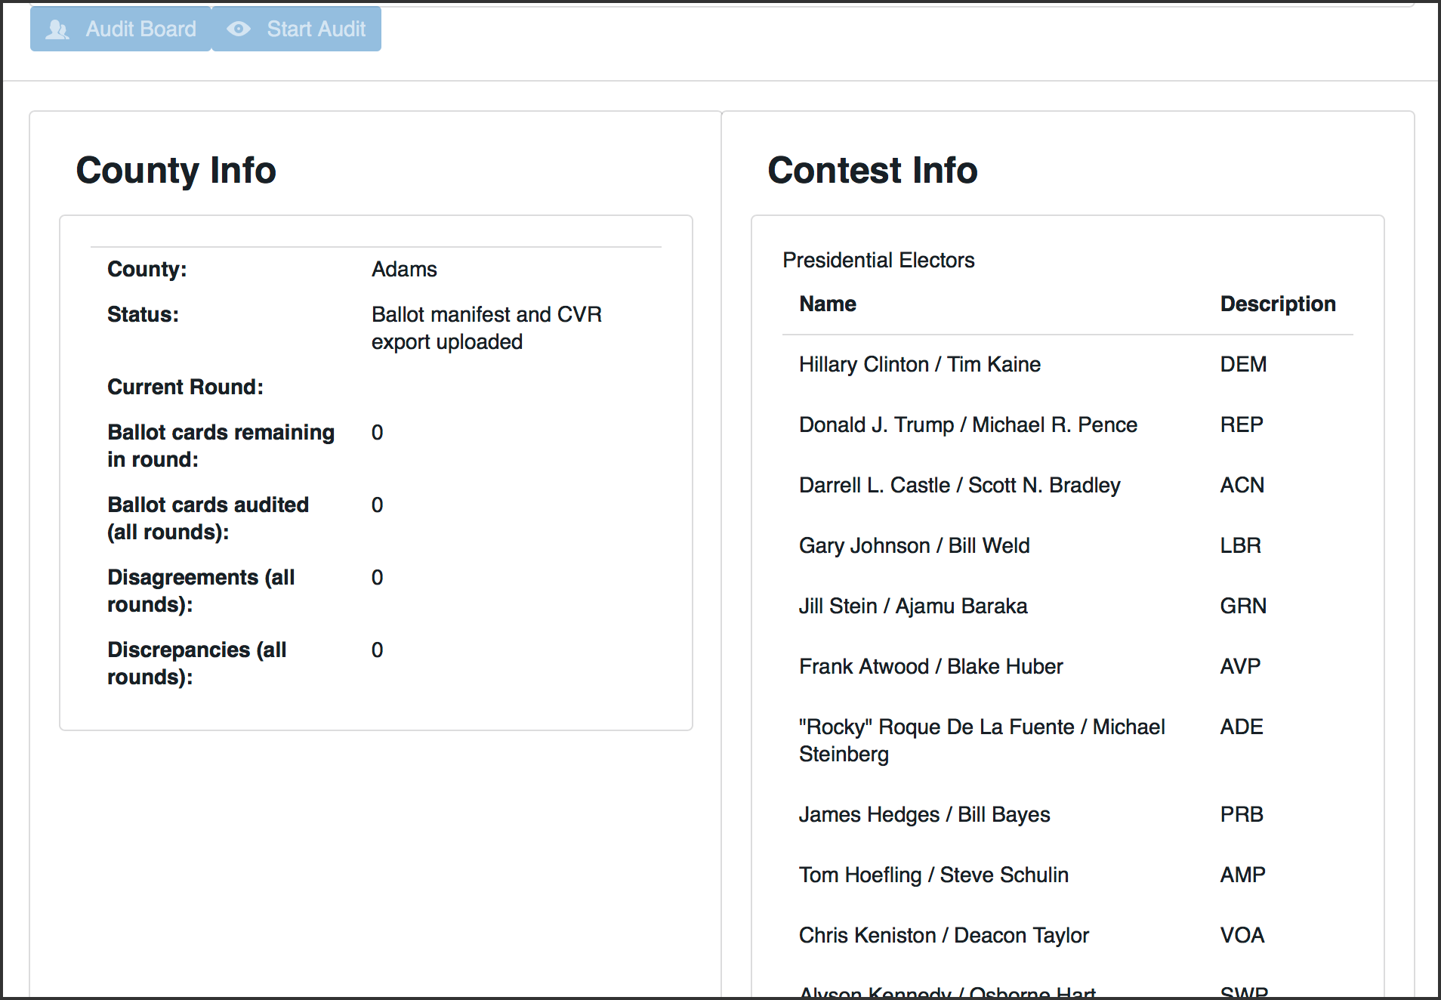

Contest Info Displayed on Home Page

At this stage in the audit process the County must wait for the Department of State to choose which contests to audit and what the risk limits will be on those contests. Once the Department of State has started the audit, the County may continue to the next step of the audit process.

## Monitoring the Audit

While the audit is on-going, the County Info table shows how many Ballot Cards are required for the current round, and how many have already been audited. The number of "disagreements" is the number of ballot cards on which the Audit Board could not come to complete consensus. The number of "discrepancies" is the number of ballot cards where the Audit Board's interpretation differs from the interpretation in the uploaded CVR file, or where the ballot card in question could not be found.

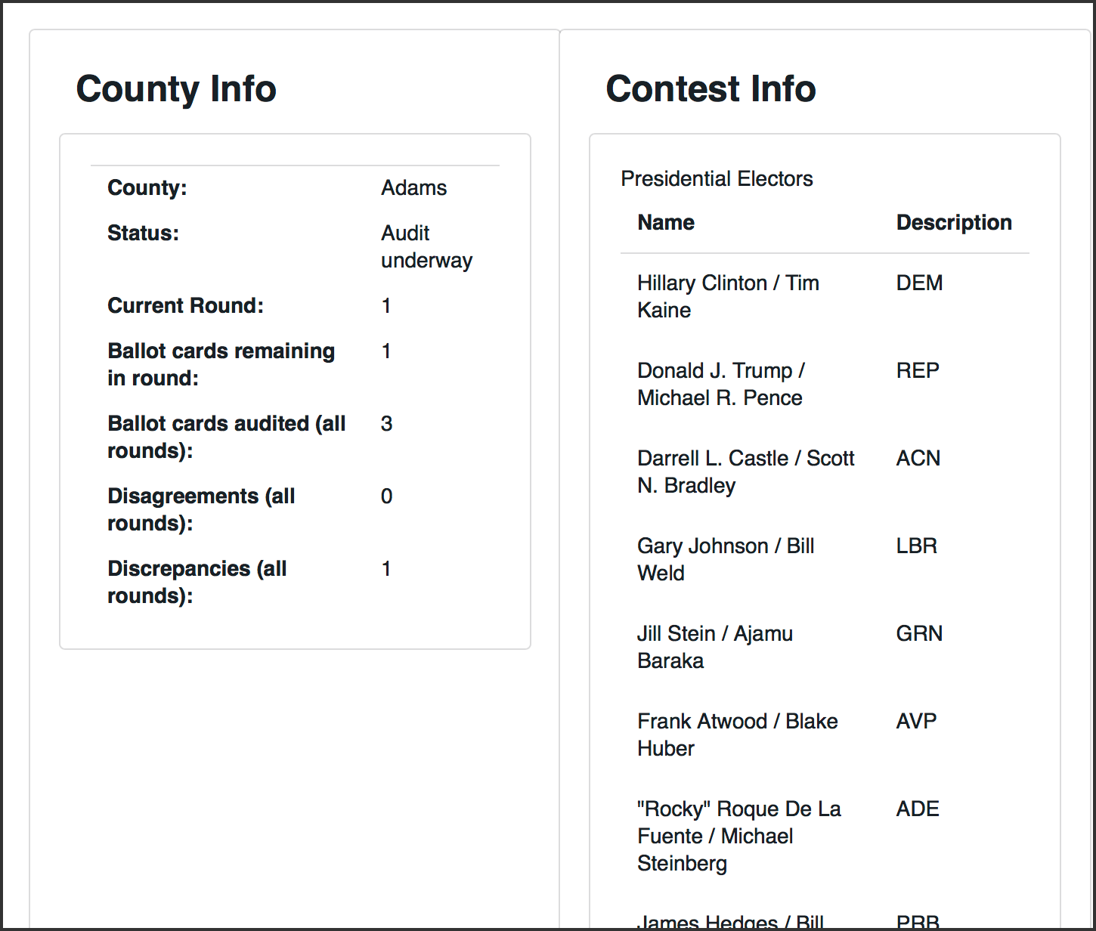

County Home Page During Audit

# Audit Board Functions

To sign the Audit Board in or out, click the "Audit Board" button on the County home page.

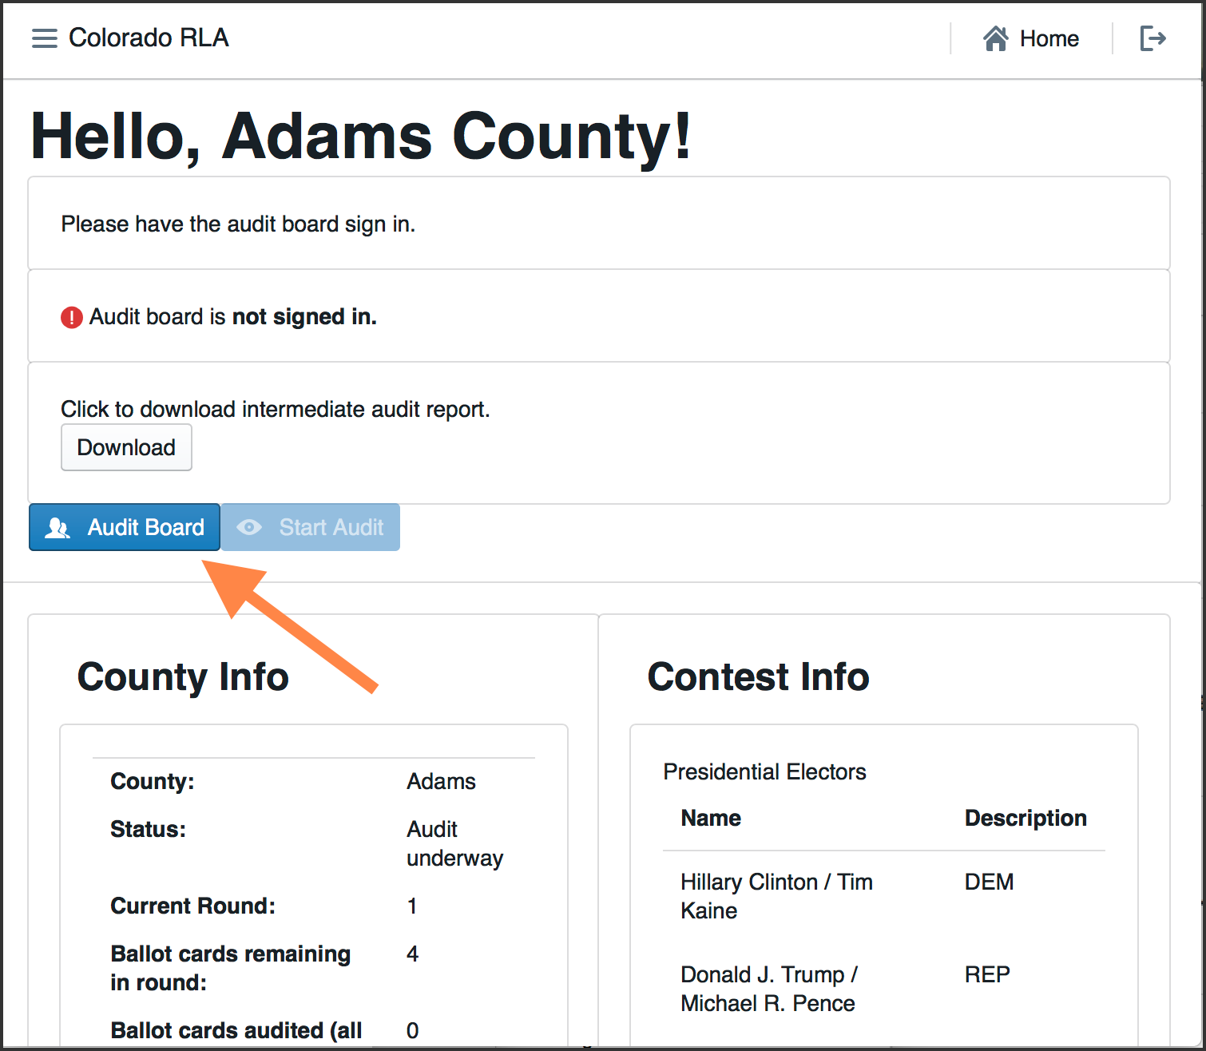

Audit Board Sign-In Button

Another way is to use the navigation menu.

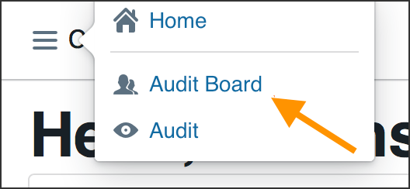

Navigation to Audit Board Identification Page

Either method will take the user to the Audit Board page.

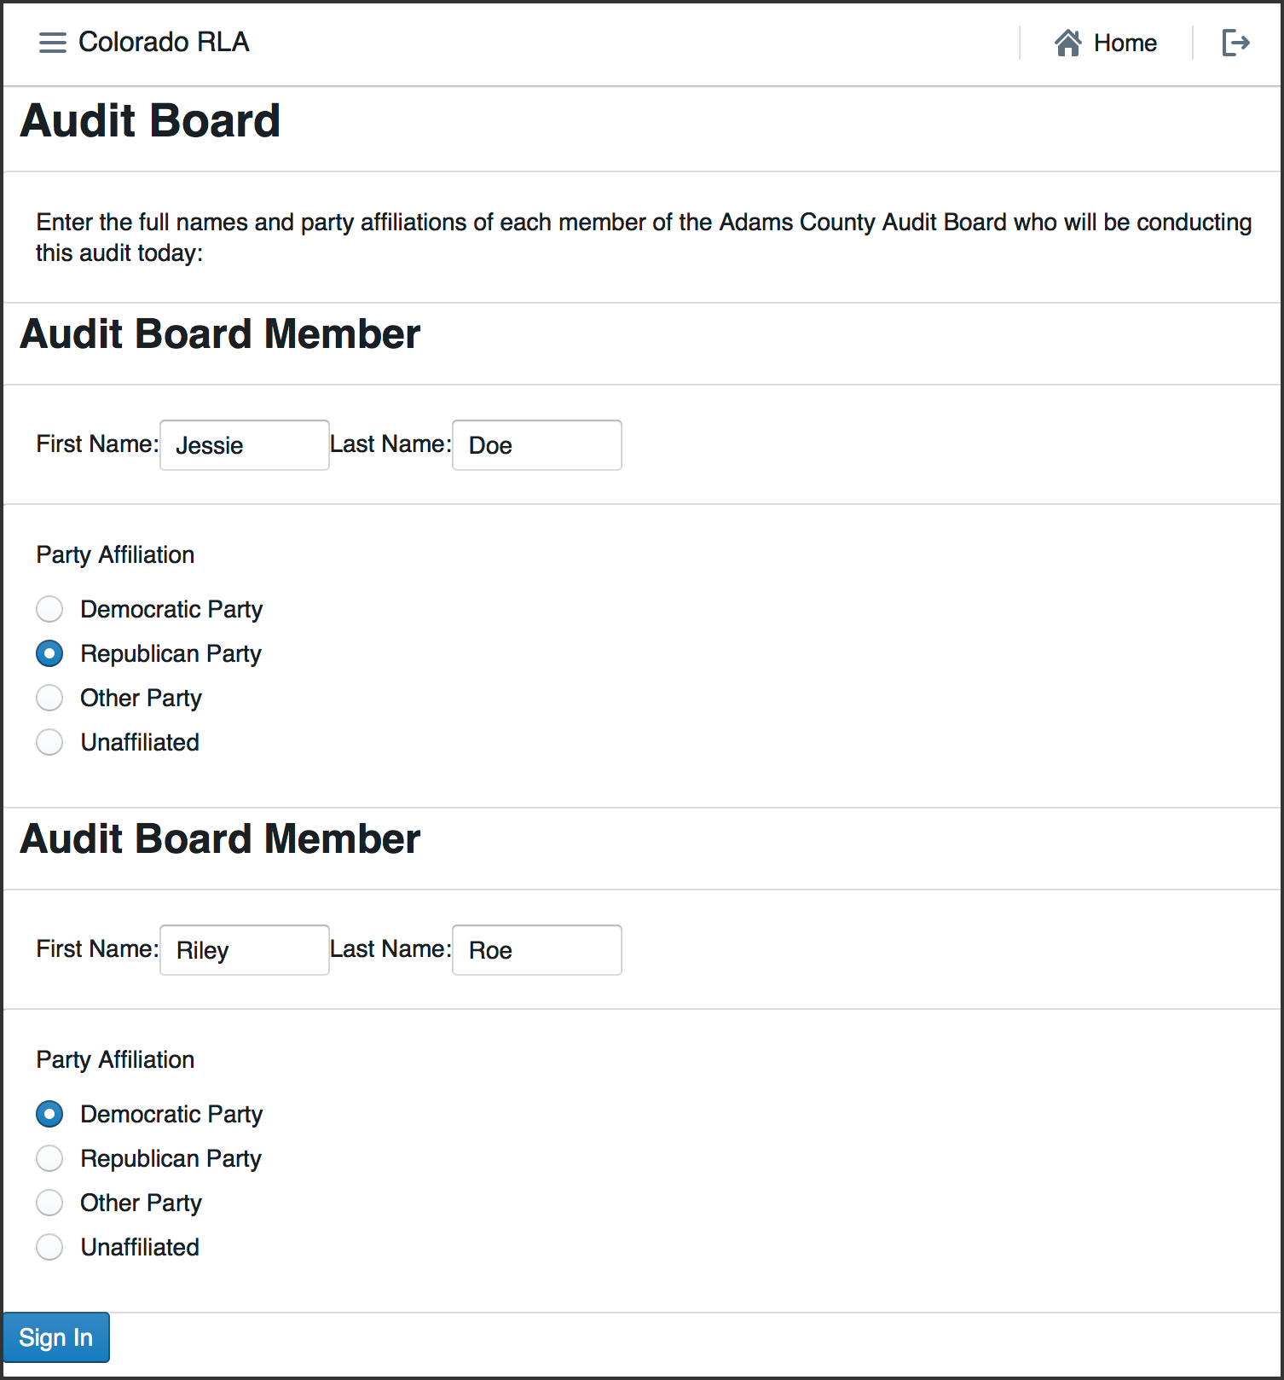

Audit Board page

## Audit Board Sign In

The Audit Board does not log directly into the RLA Tool with usernames and passwords. However, whenever the Audit Board begins to interact with the RLA Tool, either at the beginning of an audit round or after taking a break, there is an informal sign-in process. Note that all audit board members must input first and last names as well as party affiliation. If an audit board member has only a single name, include it as they normally would on any digital input form and put "N/A" in the unused field.

After the Audit Board has signed in, the Audit Board Screen will show the names and party affiliations.

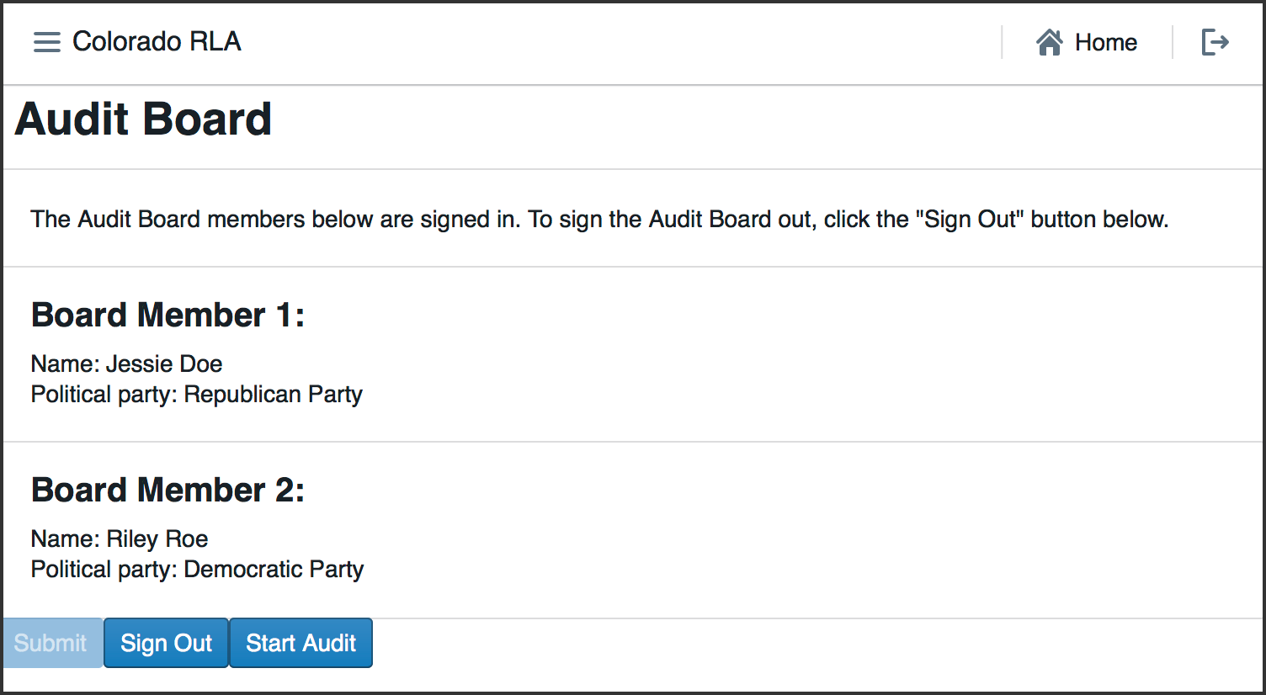

Audit Board Identity

## Ballot Card Retrieval

After the Audit Board has signed in, they can start the audit process. Use the "Start Audit" button on the Audit Board screen. Or use the navigation menu at the top left.

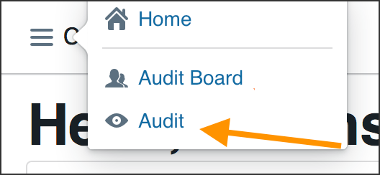

Navigation to Ballot Card Review

There is a welcome screen for the audit. Click "Next" to proceed.

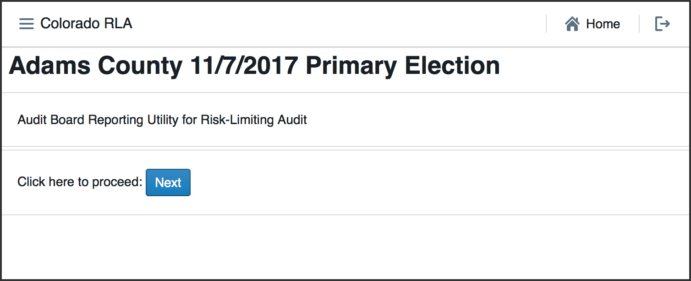

Welcome Screen

If the Secretary of State has launched a round of the audit the County user will see a list of ballot cards to be audited in the current round. The list includes the Scanner, Batch, and Ballot Position numbers, and (if available) the Storage Bin. As the round progresses the rightmost column will contain check marks for ballots that have been reviewed.

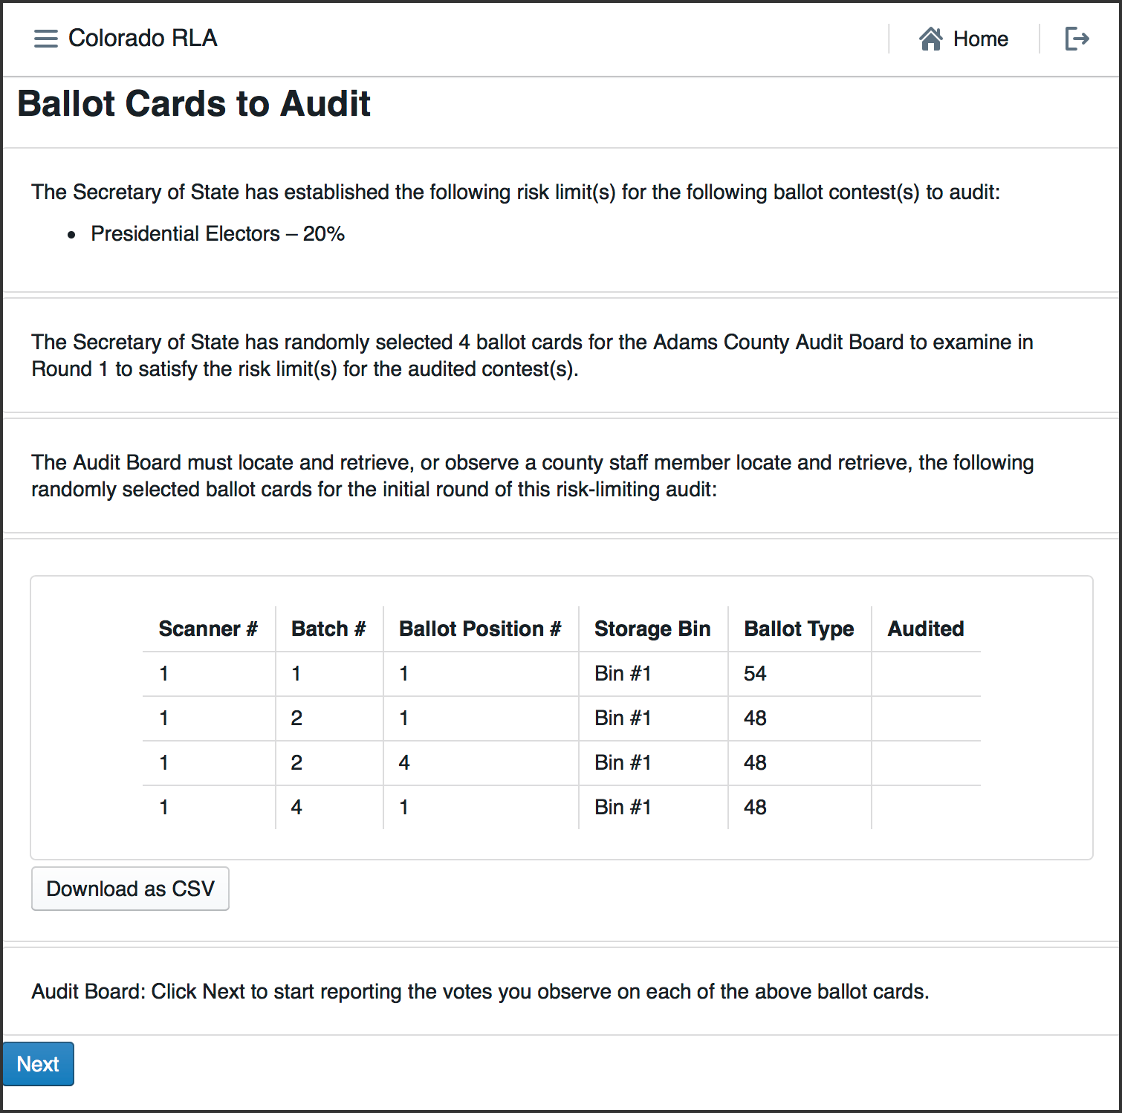

Ballot Cards to Audit

This page has a button to download a csv file that can be saved or printed, containing the list of ballots.

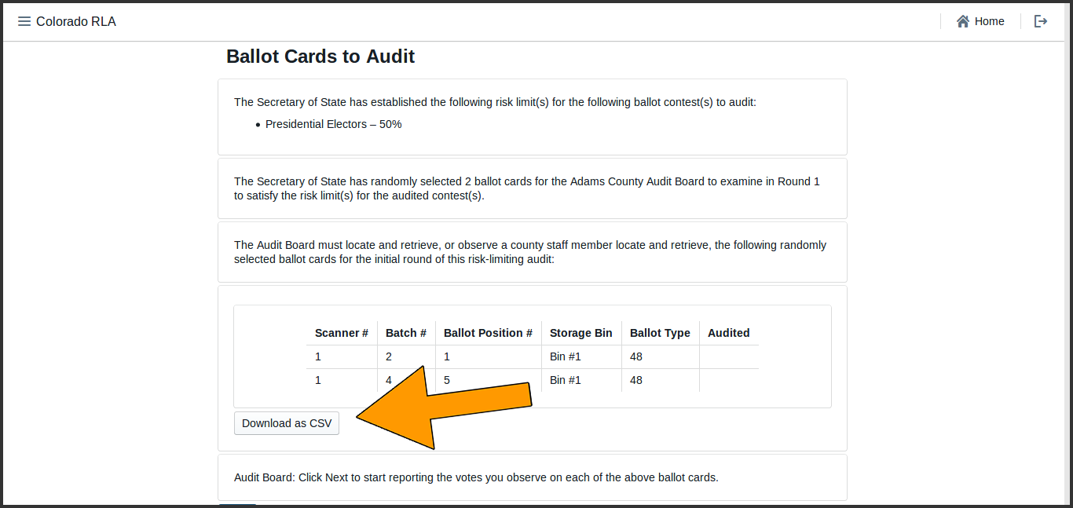

Download CSV

## Ballot Card Review

Once the ballot cards have been retrieved, click the "Next" button to start reviewing.

The RLA Tool allows Audit Board members to report the markings on each individual ballot card. Before recording voter intent, please double-check that the Ballot Type on the paper ballot card matches the Ballot Type listed on the screen.

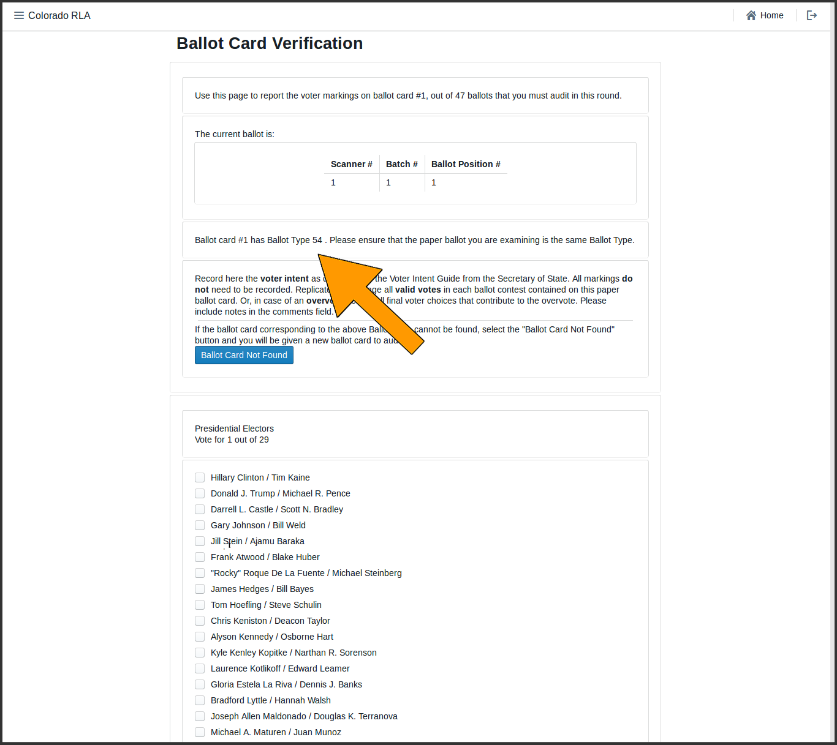

Ballot Type

If a ballot card is not found click the "Ballot Card Not Found" button.

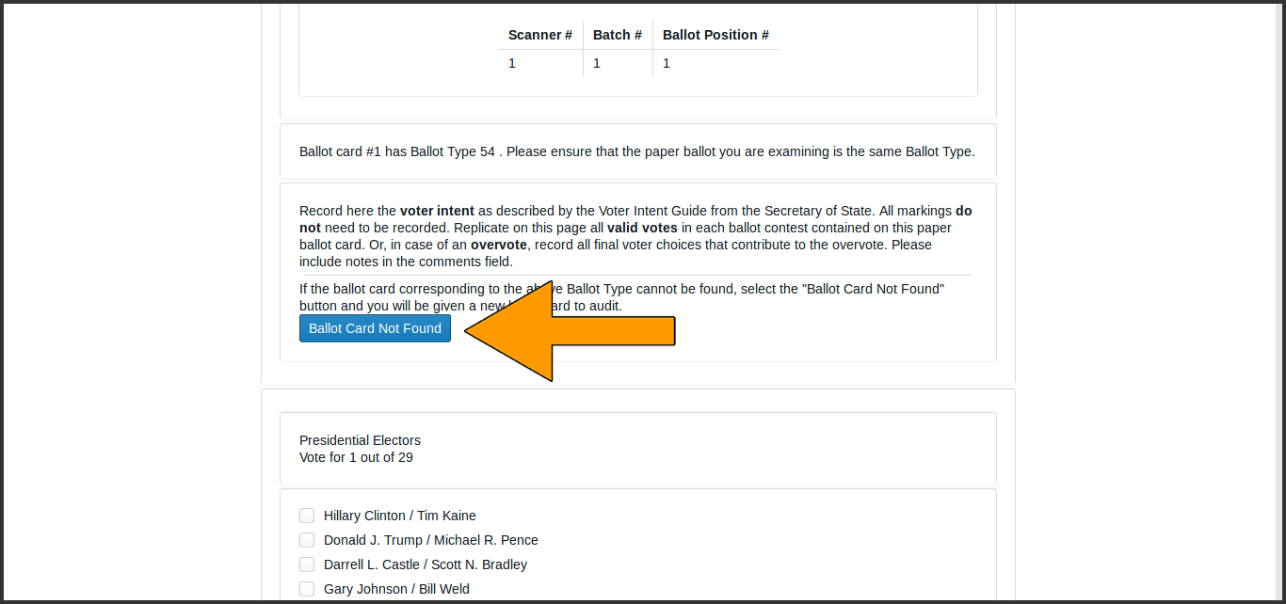

Ballot Card Not Found

Otherwise record on the screen all final voter intent marked on the paper ballot card.

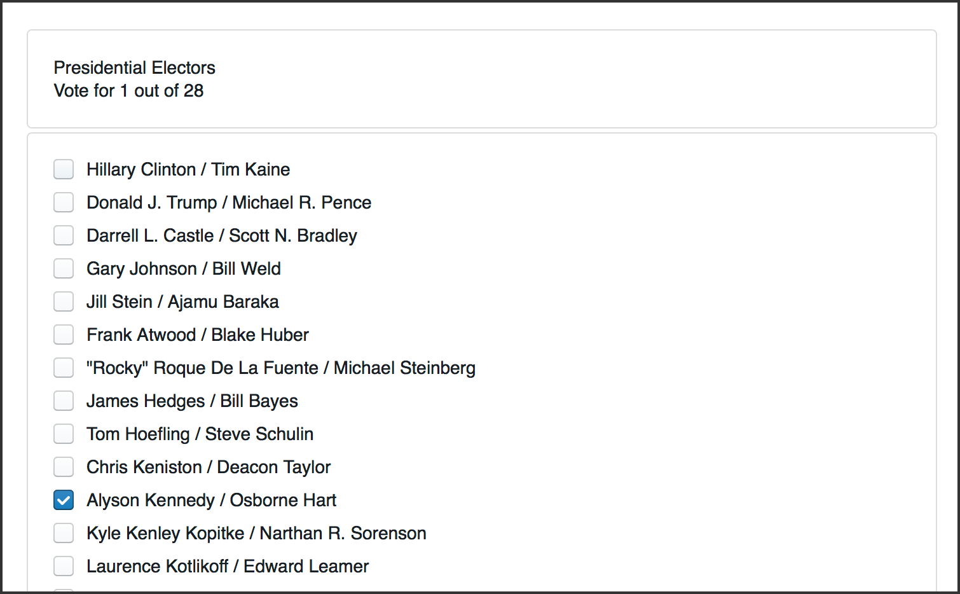

Recording Voter Intent

The list of candidates includes qualified write-in candidates.

In case of an overvote, mark each of the (too many) choices the voter intended; as the user will see on the next screen, the RLA Tool will recognize the overvote.

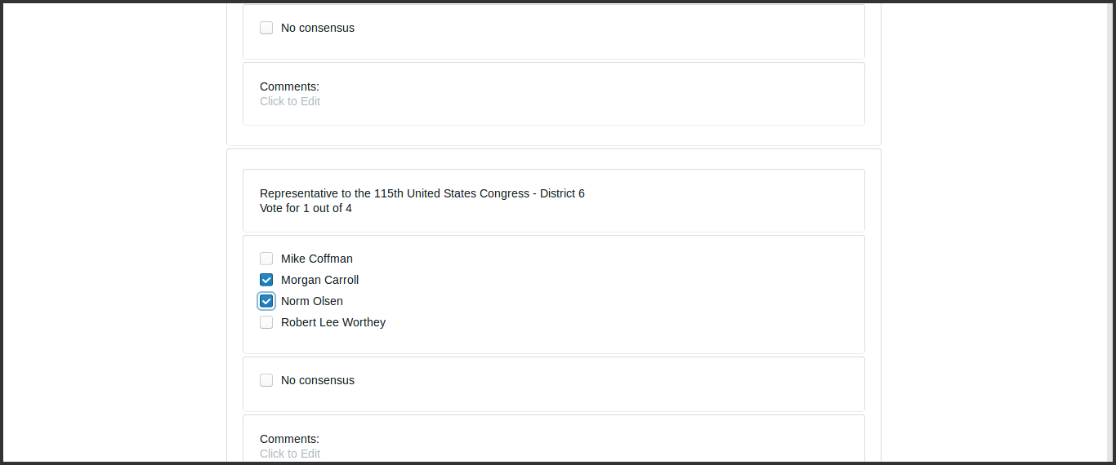

Marking an Overvote

If the Audit Board cannot reach consensus, mark the "No Consensus" box on the screen. There is a text box for any comments the audit board might wish to add in this circumstance.

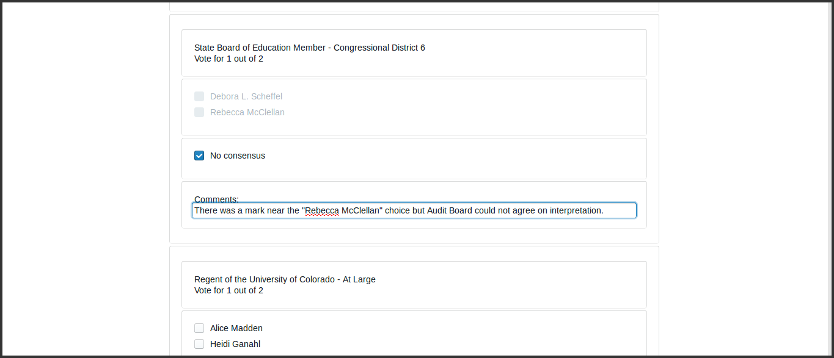

No Consensus

After entering the interpretation of the markings from any one ballot card, the Audit Board clicks the "Review" button.

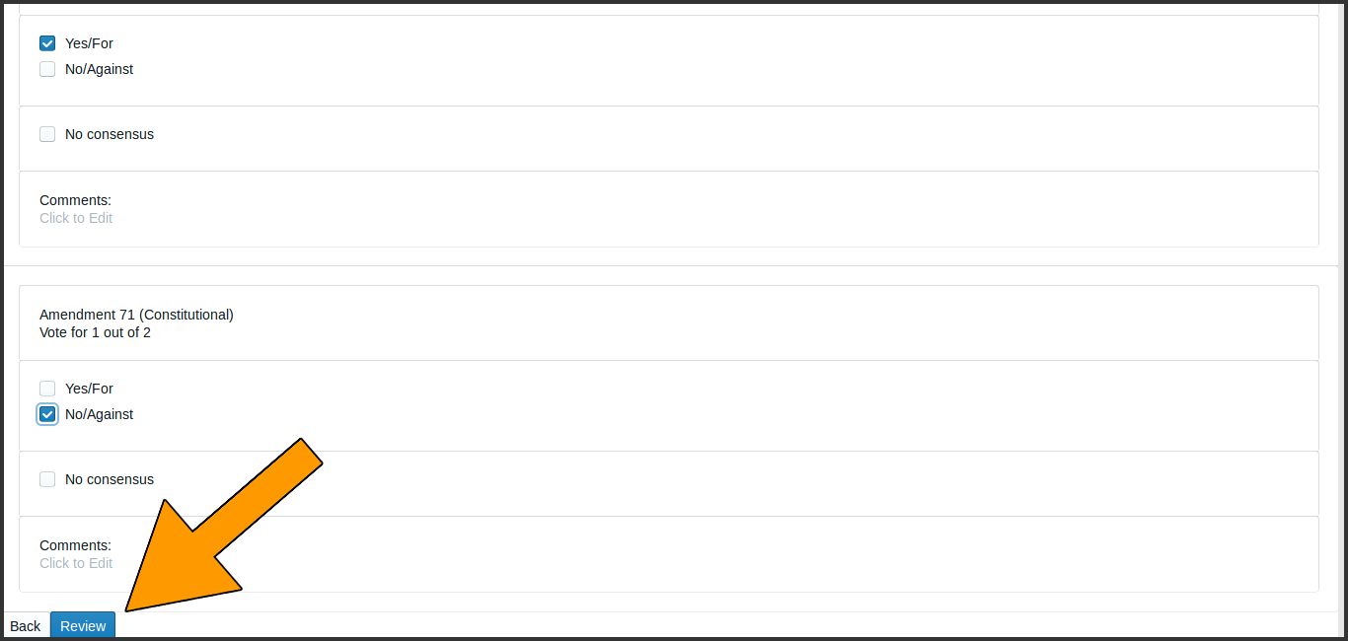

Review Button

On the Review screen, check that the information shown reflects the Audit Board's interpretation of the ballot.

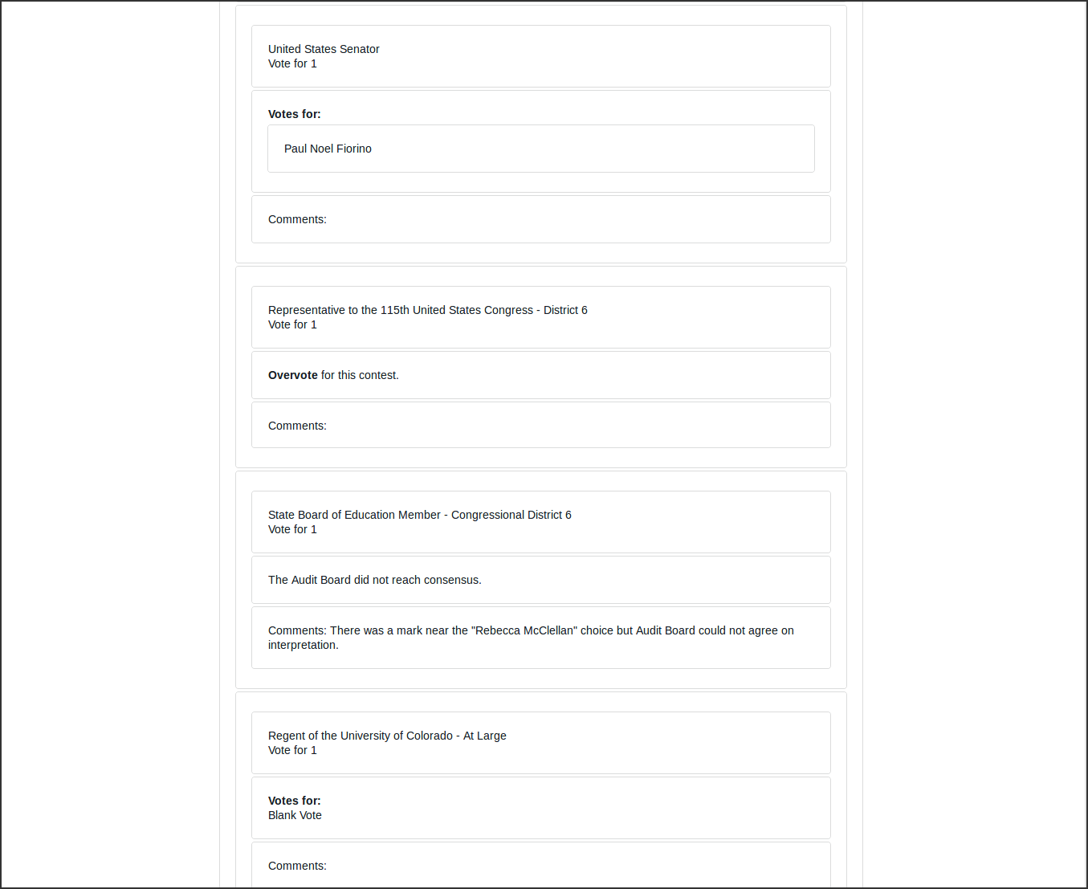

Review Screen

Note that in case of an overvote, the review screen will say "Overvote for this contest".

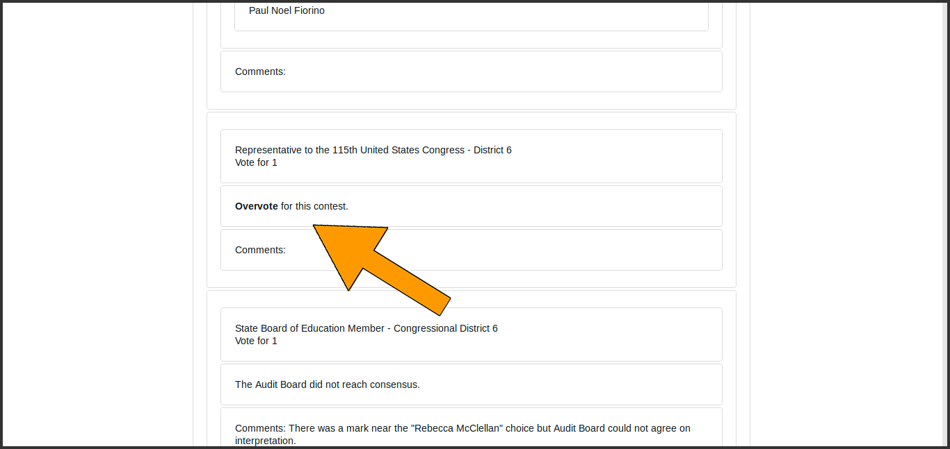

Overvote Review

If the review screen does not match the Audit Board's interpretation, click the "Back" button and correct the interpretation. If the information on the review screen is correct, click "Submit & Next Ballot".

This submission is final. There is no way to revise a ballot interpretation once it has been submitted from the Review Screen.

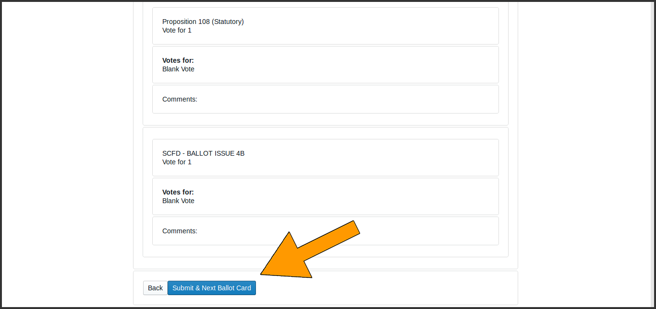

Submitting

The screen for the next ballot card will then be displayed. Review of ballot cards will continue until the Audit Board has reviewed all the ballot cards assigned to that County for that round.

## End of Round

After the last ballot card has been reviewed, the end-of-round page will appear. with boxes for the Audit Board to certify the round by entering their names as indicated. The order of the names does not matter. Clicking the "Submit" button on this page ends the County's work for the audit round.

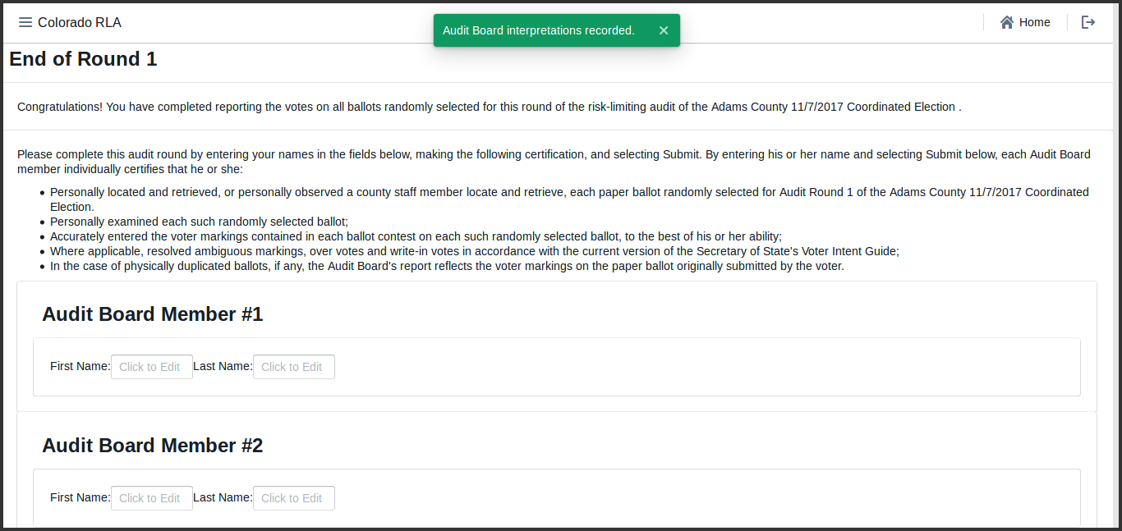

Certification

After certification, until a new round starts, the end of round page appears.

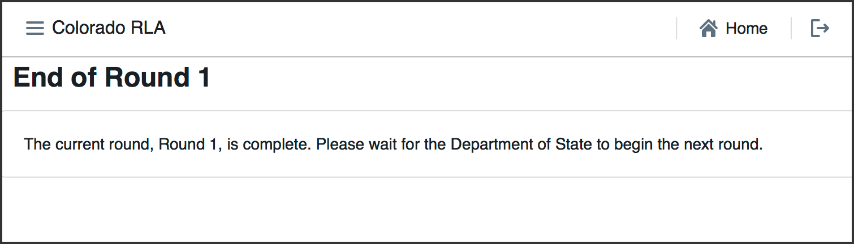

End of Round

## Signing out the Audit Board for Breaks

If the Audit Board needs to take a break, go to lunch, head home for the night, or pause their work for any reason, then the Audit Board must use the Sign Out button on the Audit Board Page.

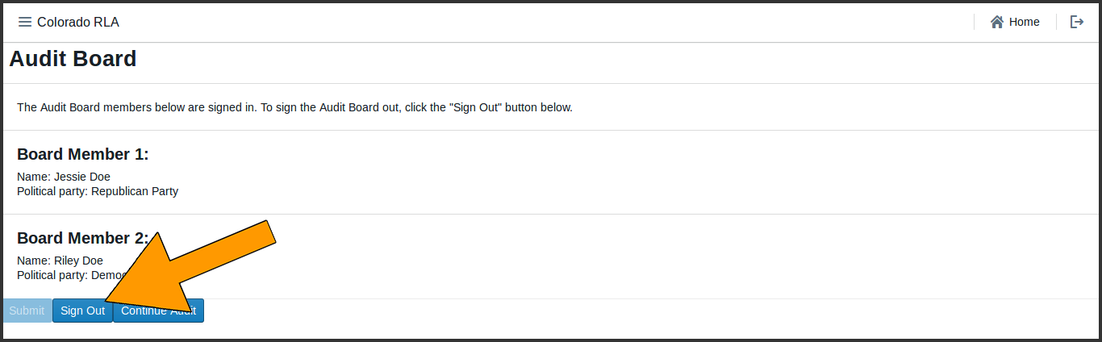

Audit Board Sign Out

Whenever the Audit Board is signed out, the Audit Board page will display the sign-in form.

# Ending the Audit

When the County has completed the entire audit, including all rounds of ballot card review required by the State, the County Home Page will appear. The page will state that "the audit is complete".

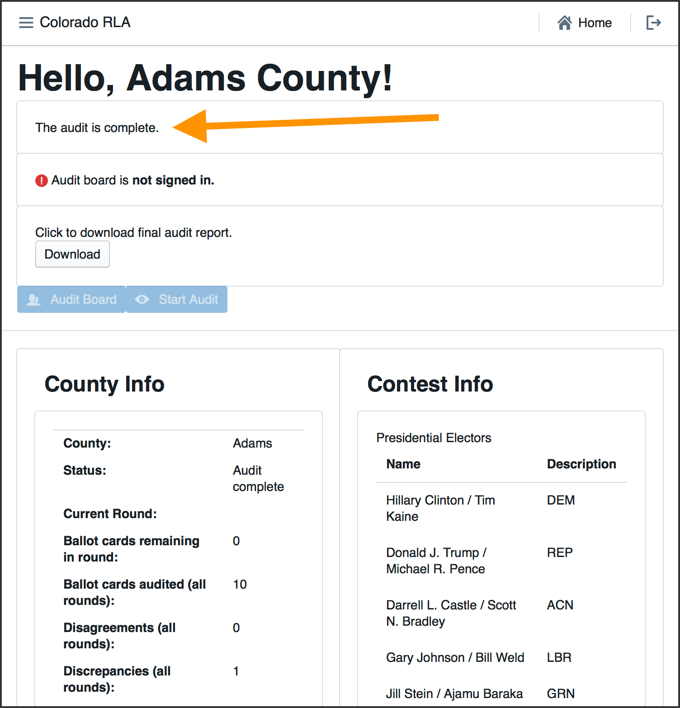

End of Audit

# Audit Reports

The "Download" button on the County Home page will download an Intermediate Audit Report if the audit is still in progress and a Final Audit Report if the audit is complete.